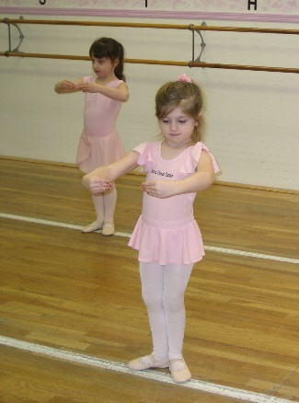

YOU ARE INVITED

Perhaps you are looking to enroll in dance classes, or perhaps you are transferring from another studio – let us help make the process and transition easy for you. Please join us for an EXCLUSIVE PDC Event just for you:

Saturday, September 19th from 9:30-1:30

Students
Attend a Free Sample Class
Play PDC Bingo
Meet the Faculty & Staff
Tour the Studio
Get fitted for Uniform Leotard & Dance Shoes
Enjoy Refreshments
View our Annual Production DVD
Receive a “Welcome to the PDC” gift

Parents
Get Answers to all your Questions
What is special about our Studio?
What classes do we offer?
What to wear to class?
What is a dance recital?
What is Roll Over Registration?
… and more

